By: Wayne Yamomo

Algorithm for Cash Register:
Step 2: Print the name and developer of the program
Step 3: Print the catalogue and the prices of each item
Step 4: Input the choice of item
Step 5:
Case choice 1: print the description and price of RADIANT ROSE and total bill, and assign bill = 1250
Case choice 2: print the description and price of CELESTIAL CARNATIONS and total bill, and assign bill = 550
Case choice 3: print the description and price of SUCCINCT STARGAZER and total bill, and assign bill = 450
Case choice 4: print the description and price of ASTRAL ALSTROEMERIA and total bill, and assign bill = 350
Case choice 5: print the description and price of TRANSCEDENT TULIPS and total bill, and assign bill = 400
Case choice 6: print the description and price of DIVINE DAFFODILS and total bill, and assign bill = 650
Case choice 7: print the description and price of CHARMING CHRYSANTHEMUMS and total bill, and assign bill = 700
Case choice 8: print the description and price of ORNATE ORCHIDS and total bill, and assign bill = 1000
Case default: print wrong input and terminate the program
Step 6: Input the payment
Step 7: Print the payment received
Step 8:
While payment < bill:
Assign deficit = bill – payment
Assign bill = deficit
Input payment
Print payment received
Step 9:
If payment > bill, then assign change = payment – bill and Print the change.
If payment == bill, then Print the "The value paid is exactly the amount needed for the bill."
Step 10: Print successful transaction of program
Step 11: Terminate the program

Output:
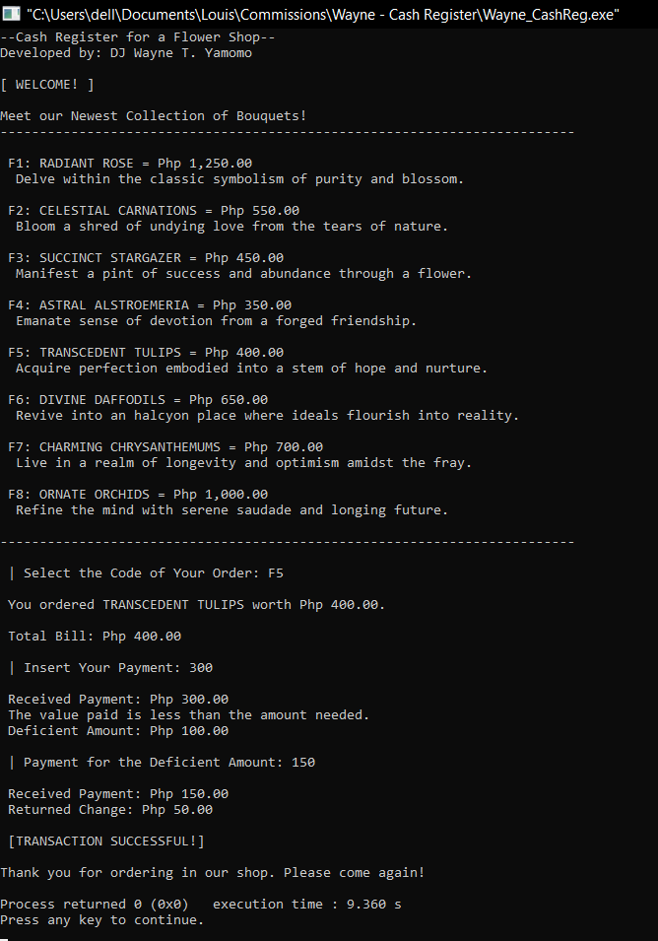
Algorithm for Area:
Step 1: Declare the functions
Step 2: Initialize the area variables to 0
Step 3: Print the name and developer of the program
Step 4: Call compute_areaTriangle() and assign its value to area_triangle
Initialize all variables 0
Input base and height
Calculate area_T = (base * height) / 2
Return area_T
Step 5: Print area_triangle
Step 6: Call compute_areaSquare() and assign its value to area_square
Initialize all variables 0
Input side
Calculate area_S = side * side
Return area_S
Step 7: Print area_square
Step 8: Call compute_areaRect() and assign its value to area_rect
Initialize all variables 0
Input length and width
Calculate area_R = length * width
Return area_R
Step 9: Print area_rect
Step 10: Call compute_areaCircle() and assign its value to area_circle
Initialize radius and area_C to 0
Initialize constant pi to 3.14159
Input radius
Calculate area_C = pi * (radius * radius)
Return area_C
Step 11: Print area_circle
Step 12: Terminate the program
